Magnetic Fields
Have you ever used a compass to navigate? Compasses point north because the Earth has a magnetic field that causes the compass needle to line up with it. Many animals demonstrate responses to magnetic field lines as well. What do magnetic fields look like?

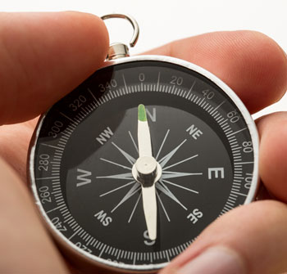

Magnetic Field Lines
A compass shows the direction of the Earth's magnetic field by lining up with the Earth's magnetic field lines. If you had a whole bunch of compasses, you could string them together and see the shape of the Earth's magnetic field. It looks a lot like the magnetic field of a bar magnet.

Reveal: Magnet Break

animation showing the magnetic poles

All magnets have a north pole and a south pole.

Iron Filings Act Like Compasses
Little pieces of iron act like little compasses. They line up with the magnetic field in their region. So when you see the iron filings lining up, it shows you a magnetic field line. In this picture you can see the magnetic field lines shown by the iron filings.

Reveal: Bar Magnet

Front

A bar magnet with iron filing around the magnet in a pattern showing the magnetic field

The magnetic field is shown by the arrangement of the iron filings.

Back

A bar magnet with iron filing around the magnet in a pattern showing the magnetic field and arrows drawn to indicate the field’s direction

Magnetic fields do not have a beginning or ending; they loop around the north pole to the south pole.

Compass Needles Point North
How does a compass work? Follow the directions to use a compass the correct way.
- Hold the compass flat.
- Rotate it so that the needle lines up with the line marking north.
- Once you know which direction is north, you can determine all the other directions.
Remember, compasses tell you which direction is north, but they don't tell you which direction to go, or where you are. You need a map for that!
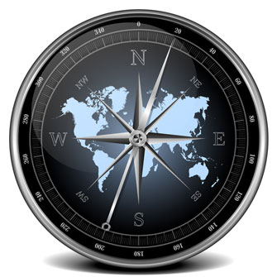

Time to Investigate
Khianna used magnets and some poster board to see what would happen when she sprinkled iron fillings on top.
She tried placing the magnets in different places underneath the poster board. She then sprinkled iron fillings on top. These are the patterns she observed.

Accordion: Field the Attraction

Directions: Select a header to expand or collapse content in each section.



Image of investigation materials including pencil, paper, iron filings, and a bar magnet.

Section 1: Single Bar Magnet

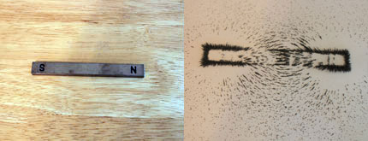
Side-by-side images of a single bar magnet, and the iron filings pattern created around the bar magnet with a sheet of paper on top of the magnet.

Section 2: Like Poles Facing

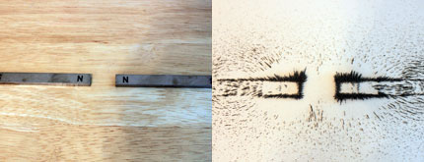
Side-by-side images of two bar magnets, with the North sides facing each other, and the iron filings pattern created around the bar magnets with a sheet of paper on top of the magnets.

Section 3: Unlike Poles Facing

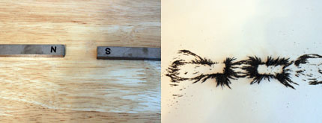
Side-by-side images of two bar magnets, with one North side facing one South side of the other magnet, and the iron filings pattern created around the bar magnets with a sheet of paper on top of the magnets.

Assignment: Field the Attraction Investigation
Using your observations, answer the questions in this assignment.

